Copulas: EURUSD and GBPUSD
Method 18 / daily log returns / empirical ranks / Gaussian + Clayton / Alpari D1 full available history

Study setup
Logical pair: EURUSD , GBPUSD
Broker symbols: EURUSD_i , GBPUSD_i
Snapshot: 2026-11-03_majors_alpari_D1
Timeframe: D1
Matched return window: 1999-01-05 to 2026-11-02 (UTC bar dates)
Matched return count n: 7202
Dropped unfinished last bar dated 2026-11-03 UTC after a tick-volume check against the prior complete day.
Margins: empirical ranks / (n+1)
Families: Gaussian (rho) and Clayton (theta), fixed before ranking
Complete matched rows (Excel): EURUSD-GBPUSD_Copula_D1.xlsx
Complete matched rows (HTML table): EURUSD-GBPUSD_Copula_D1_data.html

Method carried forward
Copulas separate marginal return shapes from dependence on the unit square. Matched daily log returns of close, ln(close_t / close_t-1), are mapped to pseudo-observations u_i = rank(x_i)/(n+1) and v_i = rank(y_i)/(n+1). A Gaussian copula parameter rho is the Pearson correlation of Phi^{-1}(u) and Phi^{-1}(v). A Clayton copula theta >= 0 is fit by maximum likelihood on (u,v) for lower-tail asymmetry. Quotes are not inverted. Kendall tau implied by each fit and Spearman of (u,v) are stored. Same-sample Pearson r on returns is a side check. This is not causation and not a trading signal.

Results
Gaussian rho: 0.655256
Gaussian Kendall tau: 0.454878
Clayton theta: 1.083145
Clayton Kendall tau: 0.351312
Spearman of (u,v): 0.642659
Pearson r on returns: 0.641738

Conclusion
Over 7202 matched daily rows for EURUSD and GBPUSD, Gaussian copula rho = 0.6553 (Kendall=0.4549) and Clayton theta = 1.0831 (Kendall=0.3513). Spearman of (u,v) = 0.6427; Pearson r on returns = 0.6417. This is not causation and not a trading signal.

Charts
Daily closes

Daily log returns

Pseudo-observations (u,v)
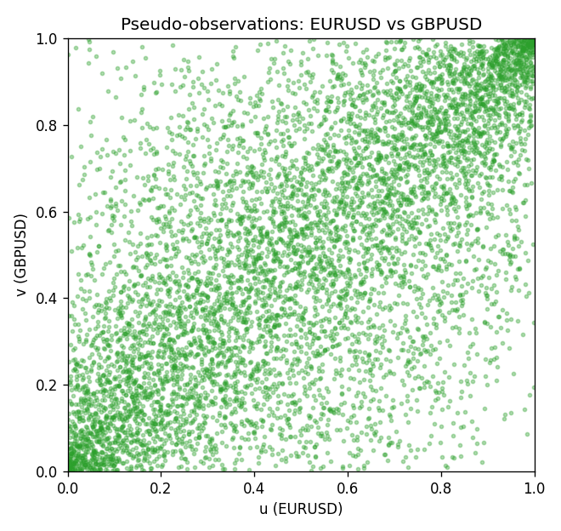

Data report
Every matched row is stored in the sibling Excel workbook named EURUSD-GBPUSD_Copula_D1.xlsx, including u and v. Embedding all rows as a Word table is impractical; this file holds column summaries and the first and last 15 matched rows.
Columns: time, EURUSD_open, GBPUSD_open, EURUSD_high, GBPUSD_high, EURUSD_low, GBPUSD_low, EURUSD_close, GBPUSD_close, EURUSD_tick_volume, GBPUSD_tick_volume, EURUSD_spread, GBPUSD_spread, EURUSD_real_volume, GBPUSD_real_volume, EURUSD_log_return, GBPUSD_log_return, u, v
Column summaries (matched calculation rows)
column | count | mean | std | min | 25% | 50% | 75% | max
EURUSD_open | 7202 | 1.1812936 | 0.15087968 | 0.8272 | 1.086065 | 1.166145 | 1.293925 | 1.5995
GBPUSD_open | 7202 | 1.5160822 | 0.2182507 | 1.06854 | 1.325005 | 1.51141 | 1.63166 | 2.1066
EURUSD_high | 7202 | 1.1864255 | 0.15147858 | 0.8326 | 1.0901775 | 1.17127 | 1.2992275 | 1.6038
GBPUSD_high | 7202 | 1.5223773 | 0.21881719 | 1.08366 | 1.329795 | 1.51815 | 1.63839 | 2.1161
EURUSD_low | 7202 | 1.1762813 | 0.15020267 | 0.8227 | 1.0819975 | 1.162535 | 1.288315 | 1.5865
GBPUSD_low | 7202 | 1.5097565 | 0.21747799 | 1.03518 | 1.3195075 | 1.503295 | 1.6243825 | 2.0983
EURUSD_close | 7202 | 1.1813323 | 0.15085599 | 0.8267 | 1.0860025 | 1.166105 | 1.2939475 | 1.5997
GBPUSD_close | 7202 | 1.5161468 | 0.21820921 | 1.06879 | 1.325125 | 1.511325 | 1.632095 | 2.1065
EURUSD_tick_volume | 7202 | 102990.53 | 173401.83 | 218 | 9388.25 | 52708 | 99433.75 | 1471626
GBPUSD_tick_volume | 7202 | 94813.509 | 153540.37 | 62 | 9988.5 | 52886.5 | 91789.25 | 1273370
EURUSD_spread | 7202 | 19.400444 | 16.577153 | 0 | 8 | 12 | 30 | 50
GBPUSD_spread | 7202 | 26.974313 | 19.194125 | 0 | 11 | 20 | 50 | 50
EURUSD_real_volume | 7202 | 4.0233049e+10 | 1.6674277e+11 | 0 | 0 | 0 | 0 | 3.6149665e+12
GBPUSD_real_volume | 7202 | 3.5555961e+09 | 8.4432361e+10 | 0 | 0 | 0 | 0 | 2.4038164e+12
EURUSD_log_return | 7202 | -7.71e-06 | 0.00580133 | -0.03123819 | -0.00324586 | 0 | 0.00325471 | 0.03433183
GBPUSD_log_return | 7202 | -2.587e-05 | 0.00564523 | -0.08388241 | -0.00313091 | 3.124e-05 | 0.00317757 | 0.03112653
u | 7202 | 0.5 | 0.28865509 | 0.00013883 | 0.25006942 | 0.49951409 | 0.74993058 | 0.99986117
v | 7202 | 0.5 | 0.28865509 | 0.00013883 | 0.25006942 | 0.5 | 0.74993058 | 0.99986117
First 15 matched rows (selected columns)
time | EURUSD_log_return | GBPUSD_log_return | u | v
1999-01-05 | -0.0048360507 | -0.0028966287 | 0.16923504 | 0.26627794
1999-01-06 | -0.011547966 | -0.00060452184 | 0.028182702 | 0.44203804
1999-01-07 | 0.0076280636 | -0.002118709 | 0.91933916 | 0.32125503
1999-01-08 | -0.010902799 | -0.0058954193 | 0.032625295 | 0.11814522
1999-01-11 | -0.007103287 | -0.0056851331 | 0.096209913 | 0.12508677
1999-01-12 | 0.0045103728 | 0.0022657001 | 0.81938081 | 0.68887963
1999-01-13 | 0.010845346 | 0.0091330396 | 0.96654172 | 0.95474108
1999-01-14 | 0 | 0.0019376331 | 0.49951409 | 0.66194641
1999-01-15 | -0.010153245 | -0.0017558204 | 0.03998334 | 0.34874358
1999-01-18 | 0.0036256946 | 0.0012112405 | 0.77467722 | 0.60391504
1999-01-19 | -0.00017235436 | 0.0018745281 | 0.48438151 | 0.65611551
1999-01-20 | -0.0031939256 | -0.0049053846 | 0.25364431 | 0.15646259
1999-01-21 | 0.0030215416 | 0.0031518998 | 0.73580453 | 0.74788283
1999-01-22 | -0.0012075213 | 0.0024781662 | 0.39344717 | 0.70401222
1999-01-25 | -0.0030251979 | 0.0012066366 | 0.26336249 | 0.60349854
Last 15 matched rows (selected columns)
time | EURUSD_log_return | GBPUSD_log_return | u | v
2026-10-13 | 0.0037402957 | 0.0036434319 | 0.7817576 | 0.77745384
2026-10-14 | -0.0037582255 | -0.0049164679 | 0.22421213 | 0.15590726
2026-10-15 | 0.0056053107 | 0.0065976411 | 0.86575038 | 0.90351243
2026-10-16 | 0.0017724895 | 0.0037592051 | 0.64986811 | 0.78425656
2026-10-19 | -0.0025394633 | -0.0017500314 | 0.29640428 | 0.34985423
2026-10-20 | 0.0023881672 | 0.0055923442 | 0.69332223 | 0.87047064
2026-10-21 | -0.00032046717 | 0.0012476328 | 0.47147022 | 0.60669166
2026-10-22 | -0.0015949606 | 0.00022396082 | 0.36387616 | 0.51853394
2026-10-23 | -0.001338521 | -0.0021146949 | 0.38289602 | 0.32181036
2026-10-26 | -0.0022706559 | -0.0024340661 | 0.31334166 | 0.29723726
2026-10-27 | -0.004152342 | -0.0023648393 | 0.20102735 | 0.30237401
2026-10-28 | 0.0022262927 | 0.0015771808 | 0.68318756 | 0.63348605
2026-10-29 | 0.0022571351 | 0.0035881935 | 0.68582535 | 0.77523254
2026-10-30 | -0.0011458446 | 0.0013450605 | 0.39872275 | 0.61460503
2026-11-02 | 0.002120569 | 0.0010971256 | 0.67694016 | 0.59447452

